DIGITAL SIGNAL PROCESSING LABORATORY
EXPERIMENT NO. 6
Design and Analysis of FIR Digital Filters Using Fourier Series and Windowing Techniques Using MATLAB
Date of Experiment: 12 October 2026

Objectives
- To design FIR low-pass digital filters using different windowing techniques.
- To compare Rectangular, Hamming, Hanning and Blackman window responses.
- To plot and analyze the magnitude response of the designed FIR filters.
- To observe the phase response of the Hamming-window FIR filter.

Program Code
clear;
clc;
close all;

Fs = 8000;
fc = 1500;
wc = fc/(Fs/2);
N = 50;

% Window Functions
w_rect = rectwin(N+1);
w_hamm = hamming(N+1);
w_hann = hann(N+1);
w_black = blackman(N+1);

% FIR Filter Design
b_rect = fir1(N,wc,w_rect);
b_hamm = fir1(N,wc,w_hamm);
b_hann = fir1(N,wc,w_hann);
b_black = fir1(N,wc,w_black);

% Frequency Response
[H_rect,f] = freqz(b_rect,1,1024,Fs);
[H_hamm,~] = freqz(b_hamm,1,1024,Fs);
[H_hann,~] = freqz(b_hann,1,1024,Fs);
[H_black,~] = freqz(b_black,1,1024,Fs);

% Display Coefficients
fprintf('EXPERIMENT 4: FIR WINDOWING TECHNIQUES\\n\\n');
fprintf('Filter Order: %d\\n',N);
fprintf('Sampling Frequency: %d Hz\\n',Fs);
fprintf('Cutoff Frequency: %d Hz\\n',fc);

fprintf('\\nRECTANGULAR WINDOW COEFFICIENTS (First 5)\\n');
disp(b_rect(1:5));

fprintf('HAMMING WINDOW COEFFICIENTS (First 5)\\n');
disp(b_hamm(1:5));

fprintf('HANNING WINDOW COEFFICIENTS (First 5)\\n');
disp(b_hann(1:5));

fprintf('BLACKMAN WINDOW COEFFICIENTS (First 5)\\n');
disp(b_black(1:5));

% Plot Responses
figure('Name','FIR Windowing Techniques Comparison');

subplot(2,1,1);
plot(f,20*log10(max(abs(H_rect),1e-10)),'k','LineWidth',1);
hold on;
plot(f,20*log10(max(abs(H_hamm),1e-10)),'b','LineWidth',1.5);
plot(f,20*log10(max(abs(H_hann),1e-10)),'g','LineWidth',1.5);
plot(f,20*log10(max(abs(H_black),1e-10)),'r','LineWidth',1.5);
grid on;
legend('Rectangular','Hamming','Hanning','Blackman');
title('FIR Low-Pass Filter Magnitude Response (N = 50)');
xlabel('Frequency (Hz)');
ylabel('Magnitude (dB)');
ylim([-100 10]);
xlim([0 Fs/2]);

subplot(2,1,2);
plot(f,angle(H_hamm)*180/pi,'b','LineWidth',1.5);
grid on;
title('Linear Phase Response (Hamming Window Example)');
xlabel('Frequency (Hz)');
ylabel('Phase (degrees)');
xlim([0 Fs/2]);
ylim([-200 200]);

MATLAB Output Screenshots
Figure 1: FIR low-pass magnitude responses for Rectangular, Hamming, Hanning and Blackman windows, with the Hamming-window phase response.
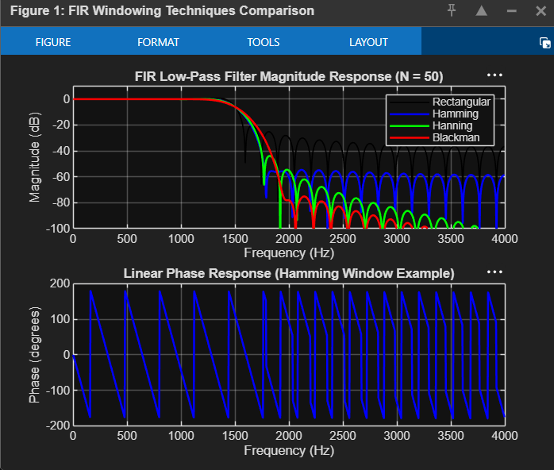

Figure 2: MATLAB Command Window output showing the design parameters and the first five coefficients for each window.
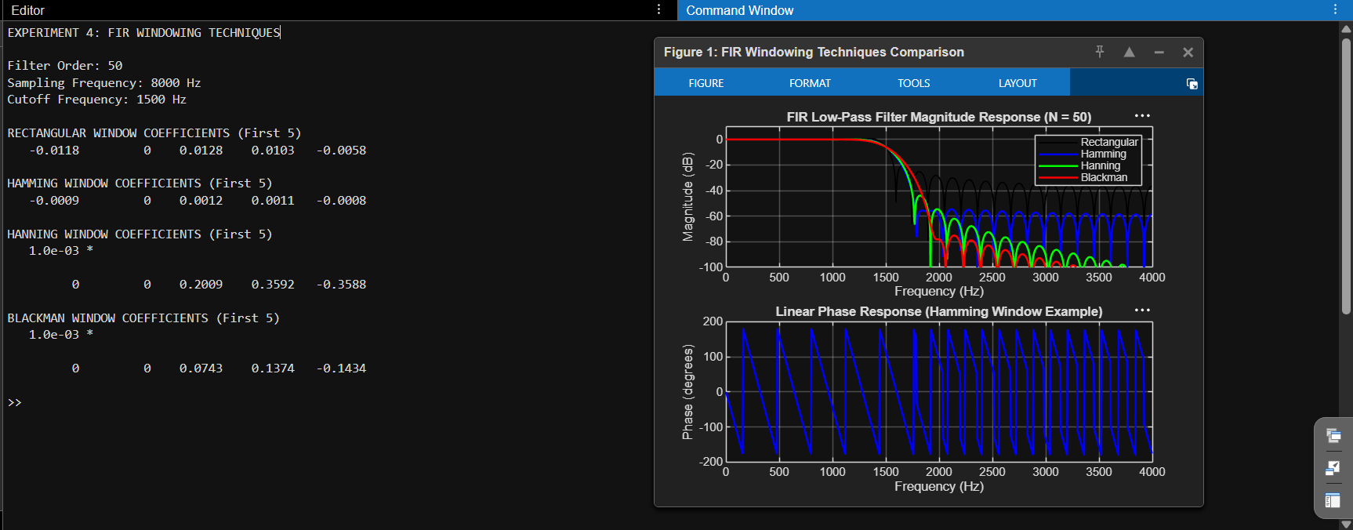

Done By
Lokesh A (192512293)
B.E. Electronics and Communication Engineering (ECE)

